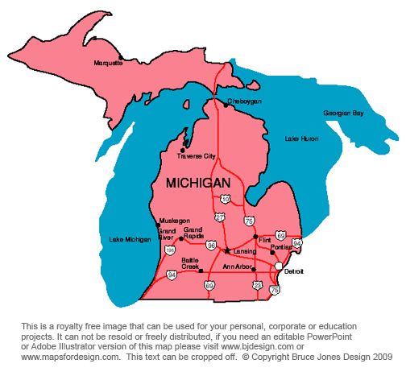
Social Studies Study Guide
Test: Wednesday, March 11, 2015

Chapter 4 Territory and Statehood pg. 106-126

Vocabulary:
Ordinance slavery township pioneer impressment reservation canal
Steamboat self-reliant constitution compromise immigrant lumberjack

Chapter 4 objectives:
- Learn about the Northwest Territory and the laws that govern it. Pg. 109
- Learn about the conflict between settlers and American Indians on the frontier. Pg. 10-11
- Learn about the causes of the War of 1812 and its impact. Pg. 112
- Understand how the United States won the War of 1812. Pg. 114-115
- Find out about the fate of American Indians after the War of 1812. Pg. 116
- Understand the impact of the Erie Canal on population growth in Michigan. Pg. 119
- Learn about life on the frontier. Pg. 120-121
- Learn how Michigan became a state. Pg. 125
- Learn how Michigan’s population boom and natural resources produced economic growth. Pg. 126-128
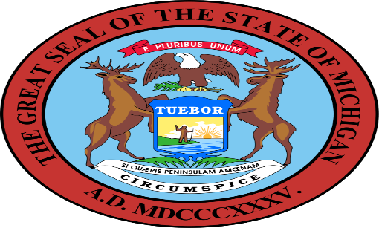
- Understand the mining boom and that it led to the creation of the Soo Locks. Pg. 127-128

